## Introduction

The purpose of this document is to establish that the anti-competitive effects of the voucher scheme for VHCN envisioned by the Cypriot authorities is limited. To do this we will first give a short description of the market structure, discuss potential issues where the voucher scheme may create undue advantage and describe countermeasures the authorities could put in place to prevent them from being realized.

## Market structure

The Cypriot market is described by a large incumbent who was formerly a state-owned enterprise, Cyta and three smaller firms which have gradually gained a foothold in the market, MTN, EPIC, Cablenet.

The three main markets which are relevant for this intervention are Mobile, Fixed, and TV services. Their respective sizes in market value in Cyprus are 218M, 124M and 30M euros. The subsidy will be a total amount of 10M over 3 years. Which means that the subsidy will be 8% of the market value of Fixed broadband or 2.7% of the market value over the three-year period.

|  |  |  |  |  |  |
| --- | --- | --- | --- | --- | --- |
|  | Retail market shares[1] | | | | |
|  | Cablenet | Cyta | Epic | Primetel/MTN | Total market value |
| ***Mobile*** | 1% | 51% | 39% | 9% | 218M |
| ***Fixed*** | 27% | 48% | 9% | 16% | 124M |
| ***Tv Services*** | 13% | 69% | 0% | 18% | 30M |

As can be seen above, four providers have heterogenous capabilities in the various markets. Specifically, Cablenet specializes in Fixed broadband (27%) and has low presence in Mobile (1%) and TV services (13%). In comparison, Epic has a strong presence in the Mobile Market (39%) but limited presence in Fixed (9%) and TV services (0%).

## 1.2 The Cypriot voucher scheme

The voucher scheme envisioned by the Cypriot authorities aims to increase the demand side for VHCN by directly subsidizing the consumer. The amount intended is a 120 euros voucher over a period of 1 year. For example, if the monthly rate to the consumer is 20 euros, the consumer would end up paying 20-(120/12)=10 euros a month. Each household can only receive a single such. The total number of beneficiaries is 82,000 households, for a total of 10M Euro subsidy over the period 2022-2025. As such this is a very ambitious project that aims to reach 82/350= 23% of households.

The practicalities of the voucher will be that the consumer subscribes, then the operator establishes the connection, the speed is then tested and if it meets required speeds[2], then the operator can claim the voucher amounts. Specifically, the voucher can only be redeemed at speeds above 200MB or above.

The amount of the voucher will be set as a function of the connection cost of households as well as the current average price of plans across operators. It has been evaluated that the voucher will not result in subsidizing more than 50% of any of the plans currently on the market in accordance with EU guidelines. (link to EU regulation here) Additionally since the voucher must be distributed within a single year, it is in accordance with EU regulation stating that vouchers should be distributed within two years. (link to EU regulation here, EU BROADBAND GUIDELINES).

## The intended function for the use of vouchers: boost demand

The intended goal by the Cypriot authorities for this voucher scheme is to increase subscription rates to fast broadband in Cyprus. According to the Digital Economy and Society Index 2022[3], Cyprus already has a 100% coverage of Fast broadband which is above EU average of 90% and 41% for very fast broadband which is below EU average of 70%. However, where Cyprus lags behind is on the take-up of these services, where 26% of households have subscriptions to at least 100Mbps fixed broadband compared to 40% of European average and 0.17% have subscriptions to at least 1Gbps compared to 7.52% EU average.

The appropriateness of demand side vs supply side policies depends on the conditions of the market. A supply side measure such as subsidizing infrastructure or co-financing fixed costs of operators would have been a better idea if the obstacle were high fixed costs to provide the services. On the other hand, if the supply was in a relatively good condition but it was simply consumer inertia which slowed down take-up of faster internet connections then a demand side measure would be most appropriate. Cyprus finds itself in the second scenario, where services are available but consumers are not opting for higher speeds.

As such, since Cyprus already has a relatively high coverage, the Cypriot authorities have deemed a demand side measure to be most appropriate for increasing the average Cypriot internet speed when it comes to stimulating up-take.

## Addressing potential market issues associated with the use of subsidies

## Bundling

Bundling is defined as the practice of offering to consumers a lower price for a certain good when it is bought with other goods versus when it is bought individually. A natural cause for concern that results due to the above market shares is that a player who is strongly situated in numerous markets can use their position to further gain market share in the other markets through bundling. Specifically in this case, if Cyta or MTN were to bundle for example TV services with Fixed broadband, they would be able to attract Epic subscribers to them. And similarly, for Cablenet and Mobile subscription services.

However, the cause for concern with bundling is limited due to the current structure of the market. Bundled services remain popular with a slight increase of fixed broadband subscriptions as part of a bundle to 78%, in comparison with 73% last year.[4] Of these bundles, 61% consists of fixed telephony and broadband access. It is only the 25% of bundled connections that include IP/cable TV access. As such, it seems bundling in the Cypriot environment does not confer large market power as only 20% of the market is bundled with TV services.

The affinity to bundle will be bounded because the Cypriot authority will limit the availability of the voucher to services that all four competitors can offer. As discussed above, this means that the only bundling that will be eligible for the voucher scheme will be fixed broadband and fixed telephony.

## Pricing

In general, Cyprus has the highest Broadband prices in Europe.

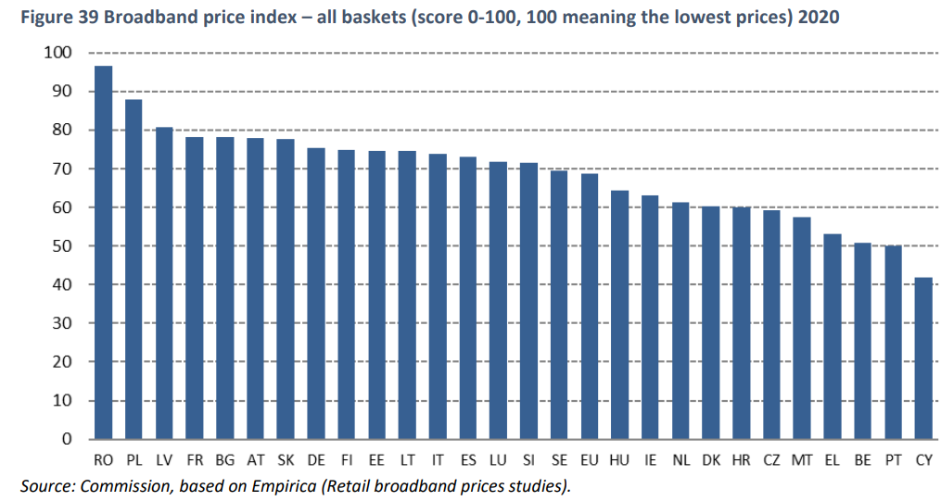[5]

Another possible cause for concern that might erupt due to a voucher scheme is that the providers will use this as an opportunity to increase their prices as consumers may make purchasing decisions based on cutoffs of monthly expenditures. For example, consumers may only consider purchases which do not exceed a certain proportion of their income, which would result in very inelastic choices for cheap products and relatively more elastic for expensive products. This would give a strong incentive to providers to increase the lower priced services.

To ensure that this does not occur, the Cypriot authority will ensure that the pricing of services which are not affected by vouchers will homogenous across competitors (whether or not the services is eligible for vouchers).

The voucher will be a fixed and pre-specified amount (i.e., a lump-sum subsidy) and NOT a percentage of the price of the plan Otherwise, the scheme would render the demand relatively more inelastic than before the introduction of the scheme, which could give the operators an incentive to increase prices, which would be counter-productive given that Cypriot prices are already significantly above the EU average. If the voucher is of a fixed amount, operators will still have the incentive to compete on the economic terms of their respective offers.

Cablenet is the provider who disproportionately has installed cable in Cyprus. This means Cablenet has lower costs to reaching the required speeds than the other operators. As such a higher portion of the voucher scheme will go directly into recuperating operational costs rather capital costs. As such, it is not the incumbent who will disproportionately benefit but it’s competitor.

## Distortive demand

## Since the voucher scheme can only be used to get a 200MB and more, the scheme is unlikely to distort existing demand in favour of lower speed services. Perhaps more importantly, the scheme can be used to upgrade existing connection to above 200MB. More importantly, the voucher should be used to improve the subscriber’s connectivity. Conditioning eligibility on the highest (1Gbps for Cyprus) may give some consumers the incentive to change plan not because they have a need (or willingness to pay) for it, but just for the sake of using the voucher. As the FTTH network is only accessible in urban areas of Cyprus, the policy that would consist in conditioning eligibility on the highest speed possible would limit the scope of the intervention to improving the connectivity of already well-connected consumers for whom access to an even faster connection may have little added value. By setting the threshold for eligibility at a lower level (200Mbps), which is what the Cypriot authorities propose, the consumer surplus generated by the voucher scheme is expected to be greater. Lock-in

The voucher as is will be locked into the initial service provider. The consumer will be permitted to switch operators during the period of the voucher (1 year) but the voucher will not be transferred to the new provider.

The effects of this kind of lock-in are expected to be limited due to the fact that the initial service provider will incur a significant fixed cost to connect the household to the network. The Cypriot authorities have purposefully designed the voucher in this way as it is of sufficiently low value to enable the initial operator to recuperate the fixed cost without subsidizing operating costs and hence will not affect the prices, this is in accordance with the EU broadband guideline which allow for two-year lock in.

## Wholesale market

Ordinarily the presence of a two-tiered market in the sense of retail and wholesale, would represent a market power risk. This is because a subsidy which is meant to target one part of the supply chain may in fact reach another part, generally, the subsidy will reach the portion of the supply chain that has the least competition. As such, It is important to establish why this will not occur on a particular intervention.

The wholesale market in Cyprus telecoms is a duopoly between Cyta and MTN for Fixed broadband and a duopoly between Cyta and Epic for Mobile. As seen below, however, these figures are subject to change as Cyta, Cablenet and Epic are currently investing in new infrastructure with the aim of increasing connectivity to 90% of premises by 2026. Epic has specifically secured 19M from the European Investment bank which will double the number of homes which it can connect to fiber (from 25k to 50k homes).

The size of Mobile and Fixed wholesale markets are, respectively, 26M and 20M Euros. [6]

|  |  |  |  |  |
| --- | --- | --- | --- | --- |
|  | Wholesale market share[7] | | | |
|  | Cablenet | Cyta | Epic | Primetel/MTN |
| ***Mobile*** | 0% | 68.6% | 29.6% | 1.8% |
| ***Fixed*** | 0% | 40% | 2% | 58% |

However due to the nature of the subsidy, which will be directly to consumers, the relative negotiating positions of these actors will be unaffected. That is, since this is a demand side subsidy, the relatively low competition in the wholesale market will not affect the retail market. As such this subsidy is of low risk for the re-distribution of profits among firms.

Additionally, the Cypriot authorities have historically obligated Cyta and other wholesalers to provide equitable conditions for the use of their infrastructure, where most recently such a measure has been enforced on Cyta which has resulted in Cyta paying a fine. The NRA has full regulatory authority to limit the prices that Cyta can charge when selling wholesale to MTN and Epic. As such the wholesale structure of the market is unlikely to be negatively affected by the voucher scheme.

* 1. Competition

The Cypriot telecoms market has a double edged sword to it in the sense that the incumbent, in fact has the best prices, as be seen below. Cyta has the lowest monthly cost of all providers and is the only one who offers services to construct a connection to currently poorly connected houses.

This means that if Cyta increases its market share, we can expect the prices to decrease. Which mean that in the case of Cyprus, monopoly power has rather limited negative effects on market power.

|  |  |  |  |
| --- | --- | --- | --- |
| **Provier(speed)** | **Existing customer annual rate** | **New customer annual rate** | **Installation for a new customer** |
| Cyta(300Mbps)[8][9] | 475.68 | 622.8 | 111.4 |
| Epic(300Mpbs)[10] | 509.88 | 719.88 | 182 |
| Primetel(250Mbps)[11] | 509.88 | 509.88 | 182[12] |
| Cablenet(200Mbps)[13] | 598.8 | 598.8 | 182 |

To get a better sense of these prices, refer to the graph below:

Additionally, Cyta, being the incumbent, must abide by regulations that other providers do not have to. For example, Cyta must rent its network at a reasonable price such that it cannot gain undue advantage on its competitors. On the other hand, Cablenet, has a fully private networks that is not subject to the same terms, which means that Cablenet may not rent its network. This structure means that Cablenet is likely to capture a higher share of the final retail price, which further weakens the incumbents market power.

As described above then, Cyta, being a strong presence in numerous markets faces two layers of competition, one layer is on network production from Cablenet, and the other on service provision by all 3 other players. This means that every part of the supply chain is subject to competitive pressure. We therefore assess the competitive effects to be quite mild or even against the incumbent.

* 1. Network effect

A boost in demand would immediately decrease the average cost of connecting households to the network. As a concrete example, imagine a tower that is connecting to houses. This tower has a fixed cost to operate and the marginal cost of operating each house is relatively small. An increase in demand, especially new connections, is likely to mean that each tower connects to more houses. This means it would allow for a spreading of the fixed cost of operation over a higher number of houses and hence to a lower average cost, which, in a competitive market should entail lower prices.

As such we expect the network effect not to raise prices.

## Technological effects

Under symmetric circumstances a flat subsidy should benefit all players equally. If however there are conditions attached to the subsidy then a differential ability to meet those conditions may imply that the subsidy will not have neutral effects. An especially important feature which will violate the non-neutrality of the subsidy are the heterogenous technological abilities.

The current structure of the market is such that the basic services are DSL and the upgraded services being Cable with very few households having the ultra-fast services(FTTH). The main operator that provides cable is Cablenet with MTN and Epic slowly developing similar capabilities. In general, Cyta is used relatively more frequently among users who opt for slower connections.

As such, since consumers choose other providers when opting for faster speeds, it is expected that this trend will continue should the demand rise. Since the voucher is expected and intended to increase the internet speed of consumers, it would also be reasonable to expect that consumers will shift to the other providers who are more popular with the higher connectivity. This implies that the effect of the subsidy on the market will be pro-competitive.

# Conclusion

To conclude, although a subsidy has potentially anti-competitive effects, we find that the specific circumstances of the market make the use of the subsidy a relatively low risk endeavor. This is because the Incumbent does not specialize in high speed internet and faces regulatory pressures that do block funneling of the subsidy to incumbents interest. Additionally, the incumbent is not in fact a force leading towards anti-competitive practices but sets a standard with lower prices.

1. This data is collected by the national regulatory authority of Cyprus(Henceforth, NRA)
2. 1 Gbps download speed, and 200 Mbps upload
3. https://digital-strategy.ec.europa.eu/en/policies/desi
4. Digital Economy and Society 2022, Cyprus(DESI), pg.4
5. Digital Economy and Society Index (DESI) 2021 Thematic chapters
6. NRA data
7. NRA data
8. Note that Cyta offer a cheaper installation cost for existing customers but we assume a worse case scenario and take the higher price
9. [*https://www.cyta.com.cy/cyta-fiber*](https://www.cyta.com.cy/cyta-fiber)
10. [*https://www.epic.com.cy/el/page/RqyDTLifS/epic-fiber*](https://www.epic.com.cy/el/page/RqyDTLifS/epic-fiber)
11. [*https://primetel.com.cy/home-fiber-plans-en*](https://primetel.com.cy/home-fiber-plans-en)
12. Note that we do not have data on Primetel and Cablenet Installation price for new customers
13. [*https://cablenet.com.cy/%cf%80%ce%b1%ce%ba%ce%b5%cf%84%ce%b1-internet-3/*](https://cablenet.com.cy/%cf%80%ce%b1%ce%ba%ce%b5%cf%84%ce%b1-internet-3/)